E6: Strains in a Ring under Combined Bending and Extension

1. **Objective:**
2. To measure strains using bonded foil strain gauges in combination with a Wheatstone Bridge.
3. Compare with linear elastic solution in a “proving” ring (circular beam with rectangular cross-section) subjected to combined extension and bending with strains measured from experiment.
4. **Theory/Background (related to the experiments):**

A thin ring with internal radius ri that is being pulled diametrically by force F. the quarter ring's free body diagram using symmetry. At θ= 0, the shear force is zero, leaving only an axial load of F/2 and an unknown bending moment M0 acting on the cross section. Using energy method, the bending moment at any θ can be calculated and is given by:

M𝜃 = 𝐹r/2 (𝑐𝑜𝑠𝜃 – 2/𝜋 ), which gives at θ = 0, 𝑀0 = 𝐹𝑟/2 (1 – 2/𝜋 ).

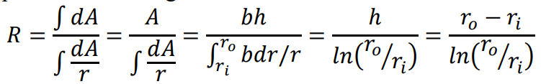 Unlike in a straight beam the neutral axis does not coincide with the centroid of the cross-section in the case of a curve beam. Determining the neutral axis' location is crucial. When the integral of the axial force over the entire cross-section is set to zero, the neutral axis is identified as the fibre along which there is no stress from bending.This gives us the location of the neutral axis as:

Where, b is the width of the ring, ri and ro are the inner and outer radii of the ring with h = ro- ri. So, at any r from the center of the ring, the axial stress due to bending at is given by:



Here, y is the distance of the fiber from the neutral axis, 𝑒 = 𝑟̅− 𝑅 is the eccentricity, 𝑟̅= ∫ 𝑟𝑑𝐴 𝐴 , 𝜅 is the curvature, E is the elastic modulus. The value of 𝑟̅for the rectangular beam is the mean of the inner and outer radii, i.e., 𝑟̅= ∫ 𝑏𝑟𝑑𝑟/𝑏ℎ 𝑟𝑜 𝑟𝑖 = 𝑟𝑜+𝑟

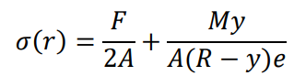Keep in mind that the bending moment's maximum value occurs at the location where the load is applied. The stress in the cross-section is caused by bending and axial loads acting together because we are applying linearized elasticity to a curved beam and an axial load of F/2 is acting on the cross-section. The combined axial stress at any fiber on beam is given by:

The stress at the horizontal cross-section, i.e., at θ = 0, using r = R-y, is then give by



Which implies the strain at the inner and outer surfaces of the ring at θ = 0 are:



1. **Equipment Required:**
2. Venier calipers
3. Strain measuring bridges with bonded foil gauges
4. Circular ring
5. Weights and weight hanger.
6. **Experimental Method:**
7. Measure the dimensions of the ring.
8. Mount ring on a fixture.
9. Connect the strain gauges to strain measuring bridge.
10. Load the ring in diametrical opposite direction and note the strain value at various loads.
11. Note, before starting the measurements, balance the Wheatstone bridge.
12. **Expected outcomes:**
13. Plot the load-unload strains on all the four gauges.
14. Compare them with theoretical values.
15. Write your observations based on the results.